Teaching Material

ConClip 1 • Thermal Bridges:
Mounting of wall insulation boards
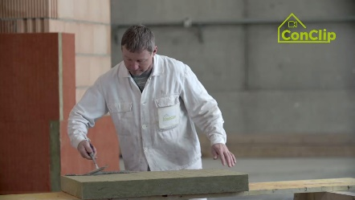 | 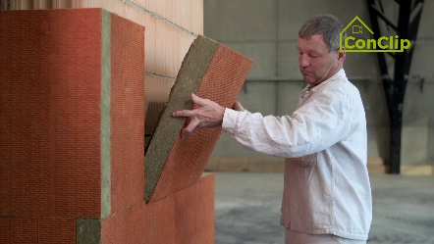 | 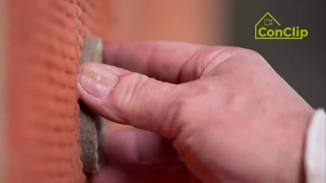

About ConClips
ConClips are short video clips (3 to 4 minutes) about the proper fitting of construction and installation parts in passive houses. As an easy understandable multimedia tool helping workers to fill skill gaps, ConClips can be integrated in vocational training and education.
The teaching material serves instructors and other experts as a basis for using ConClips in teaching that can be extended according to their own requirements.

ConClips: The making of
Each ConClip highlights one specific working process.
A worker performs the work steps in a realistic 1:1-scale model of the working environment.
An off-speaker gives short, understandable explanations to the work steps.
Additionally, the most important work steps and terms (keywords) appear as text inserts.
In the end, the most important steps and keywords are repeated.

Code of didactical practice
On the following page, you find material to the video, split in the following categories:
- The working procedure as shown in the video is divided into a sequence of comprehensible workflow steps
- The workflow steps are explained on three levels:
- What is done?
- How is it done?
- Why is it done?
- A small number of keywords relevant for the workflow are introduced and defined.
Please add the contents relevant for Your teaching – e.g. catchwords of explanation (Why something has to be done?) resp. keywords and a definition of them.
Workflow Steps
What is done? | How is it done? | Why is it done?
Installing Thermal Insulation:
Cover the insulation board surface with mortar | At least 40 percent of the insulation board surface must be covered with adhesive mortar
 | The mortar must form a continuous, about 3 centimetres high coil at the edges.
 | Three bearing spots are necessary in the middle.
Fix the insulation board on the wall. | Clean and closed joints must be ensured when installing the insulation board. | Thus, thermal bridges are avoided
 | Excess mortar must be removed immediately. | When the mortar once becomes dry, no clean and closed joints can be ensured
 | The insulation boards have to be placed shifted in each row. | Shifting the boards, also on corners, avoids the façade’s scaling off
Drill the holes for the dowels | Use the correct drill:  - percussion drill for concrete  - cutting edge drill for brick walls
 | In order to have the proper depth of the holes, an adhesive tape is placed on the drill.
 | The holes are arranged in W-shape. | The W-shape ensures good footing of the insulation boards
Insert the dowels | The dowels are sunk in the proper depth by means of an appropriate drill bit.
Close the dowels’ holes in the insulation boards with plugs of insulating material | Plugs of insulating material in the correct size are placed in the holes even with the insulation board surface. | The plugs ensure that no thermal bridge is generated.

Installing Thermal Insulation: KEywords
Thermal Bridge | Heat makes its way from the heated space towards the outside. In doing so, it follows the path of least resistance, which is a thermal bridge.  Buildings lose temperature through thermal bridges. Structural damages such as moisture and mould can be the result.

