Teaching Material

ConClip 2 • Airtightness: Window Installation in Exterior Brick Wall with Insulation
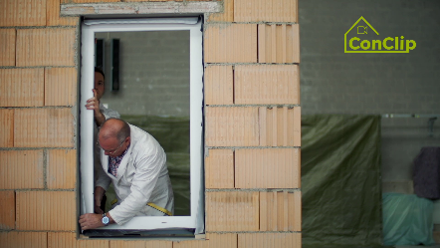 | 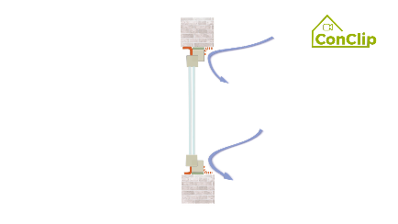 | 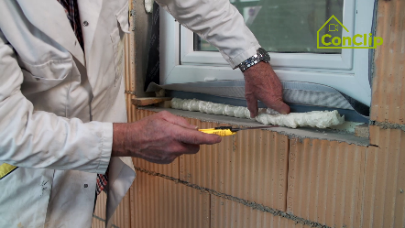

About ConClips
ConClips are short video clips (3 to 4 minutes) about the proper fitting of construction and installation parts in passive houses. As an easy understandable multimedia tool helping workers to fill skill gaps, ConClips can be integrated in vocational training and education.
The teaching material serves instructors and other experts as a basis for using ConClips in teaching that can be extended according to their own requirements.

ConClips: The making of
Each ConClip highlights one specific working process.
A worker performs the work steps in a realistic 1:1-scale model of the working environment.
An off-speaker gives short, understandable explanations to the work steps.
Additionally, the most important work steps and terms (keywords) appear as text inserts.
In the end, the most important steps and keywords are repeated.

Code of didactical practice
On the following page, you find material to the video, split in the following categories:
- The working procedure as shown in the video is divided into a sequence of comprehensible workflow steps
- The workflow steps are explained on three levels:
- What is done?
- How is it done?
- Why is it done?
- A small number of keywords relevant for the workflow are introduced and defined.
Please add the contents relevant for Your teaching – e.g. catchwords of explanation (Why something has to be done?) resp. keywords and a definition of them.
Workflow Steps
What is done? | How is it done? | Why is it done?
Window Installation in Exterior Brick Wall with Insulation:
Apply plaster on the brick surfaces surfaces of the window opening – the jambs. | Flatten the plaster so that it will be smooth and even:
 | Leave wall opening bigger than the window frame itself. Leave about 1 centimetre space on each side - the top, the bottom, left and right.
Put the self-adhesive sealing tape on both the inside and outside of the window frame | Attach the sealing tape continuously on all four sides of the window frame – inside as well as outside
 | Tighten the tape with one hand while applying it with the other.
 | In order to close the gap on the corners, consider over-lengths of the sealing tape on the corners.
Insert the window frame into the wall opening and fix it. | Fix the frame first with wedges
 | Screws are driven through the window frame into the masonry.
Before filling the installation space with polyurethane foam, You have to mount the sash. |  | Only when the sash is mounted, the window frame cannot be deformed by the hardening mounting foam.
Fill the installation space with polyurethane foam. | Apply the polyurethane foam in a constant pace.
 | After the foam has hardened well; cut it off evenly with the window frame.
Attach the self-adhesive tape airtight to the soffits. | The tape has to be attached inside as well as outside. See that the inner side is more airtight than the outer side. | Moist and cold air should be allowed to enter through the outside sealing level, but must not cross the inner sealing.
Attach plaster profiles for exterior plaster to the window.

Window Installation in Exterior Brick Wall with Insulation: KEywords
Airtightness | Building resp. envelope airtightness is the resistance to unintentional inward or outward air leakage in the building envelope. This air leakage is driven by differential pressures across the building envelope due to the combined effects of stack, external wind and mechanical ventilation systems.

