Teaching Material

ConClip 3 • Insulation:
Installation of a window sill
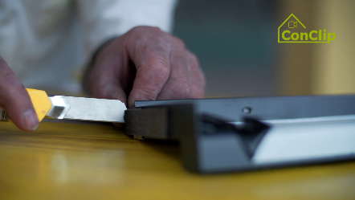

About ConClips
ConClips are short video clips (3 to 4 minutes) about the proper fitting of construction and installation parts in passive houses. As an easy understandable multimedia tool helping workers to fill skill gaps, ConClips can be integrated in vocational training and education.
The teaching material serves instructors and other experts as a basis for using ConClips in teaching that can be extended according to their own requirements.

ConClips: The making of
Each ConClip highlights one specific working process.
A worker performs the work steps in a realistic 1:1-scale model of the working environment.
An off-speaker gives short, understandable explanations to the work steps.
Additionally, the most important work steps and terms (keywords) appear as text inserts.
In the end, the most important steps and keywords are repeated.

Code of didactical practice
On the following page, you find material to the video, split in the following categories:
- The working procedure as shown in the video is divided into a sequence of comprehensible workflow steps
- The workflow steps are explained on three levels:
- What is done?
- How is it done?
- Why is it done?
- A small number of keywords relevant for the workflow are introduced and defined.
Please add the contents relevant for Your teaching – e.g. catchwords of explanation (Why something has to be done?) resp. keywords and a definition of them.

Workflow Steps
What is done? | How is it done? | Why is it done?
Insulation: Installation of a window sill
Fit the insulation under the sill. | Before fitting the insulation, consider that the final coat of plastering has to be sufficiently dry.
 | The insulation under the sill has to be fitted with a slope of 5 degrees to the outside.
Apply the sealing layer on the inclined sill area. | Use special sealing compound.
 | Before continuing with the next workflow step, this layer has to be dry!
Attach the pre-compressed sealing tape on the sill | The sealing tape is attached alongside of the window and on both sides
 | This special tape expands after being applied, so it fills the gaps between the window sill, the jambs and the window frame.
Attach additional strips of adhesive sealing tape under the sill | The strips of tape are attached under the sill in the direction of the slope
Mount the window sill and fix it. | The window sill is fixed with the proper screws.
Grout the sill connections. | Use appropriate grouting material.

Installation of a window sill: KEywords
Moisture | Water can threaten the structural integrity of a building and disintegrate materials within. Moisture brings health risks to occupants, amongst others because of the effects of mold growth and dampness on occupants.

