Teaching Material

ConClip 4 • Instulation:
Correct insulation of fascia brickwork
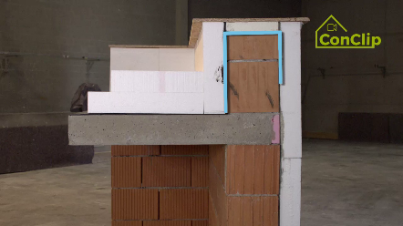 | 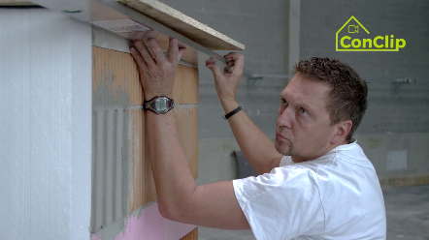 | 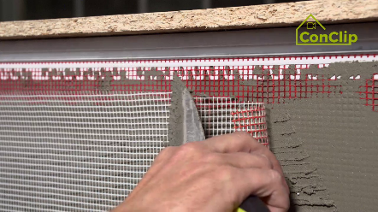

About ConClips
ConClips are short video clips (3 to 4 minutes) about the proper fitting of construction and installation parts in passive houses. As an easy understandable multimedia tool helping workers to fill skill gaps, ConClips can be integrated in vocational training and education.
The teaching material serves instructors and other experts as a basis for using ConClips in teaching that can be extended according to their own requirements.

ConClips: The making of
Each ConClip highlights one specific working process.
A worker performs the work steps in a realistic 1:1-scale model of the working environment.
An off-speaker gives short, understandable explanations to the work steps.
Additionally, the most important work steps and terms (keywords) appear as text inserts.
In the end, the most important steps and keywords are repeated.

Code of didactical practice
On the following page, you find material to the video, split in the following categories:
- The working procedure as shown in the video is divided into a sequence of comprehensible workflow steps
- The workflow steps are explained on three levels:
- What is done?
- How is it done?
- Why is it done?
- A small number of keywords relevant for the workflow are introduced and defined.
Please add the contents relevant for Your teaching – e.g. catchwords of explanation (Why something has to be done?) resp. keywords and a definition of them.

Workflow Steps
What is done? | How is it done? | Why is it done?
Correct insulation of fascia brickwork
Insulate the outer wall up to the top. | Before fixing the last before row of insulation boards, mark the insulation boards of the last row where to cut them.
 | Cut the insulation boards as marked.
 | The pre-compressed sealing tape is placed between fascia coverage and top of the insulation boards: Mark the position of the sealing tape on the fascia coverage (It has to be fixed on the front edge of the insulation board).
Adhesive mortar is applied on the whole surface of the last row of insulation boards. | The adhesive mortar is applied on the whole surface of the brickwork as well as of the insulation board.
 | Apply the adhesive mortar horizontally on one surface, vertically on the other.
Put a fitting profile on the upper end of the facade |  | By keeping water from getting behind the insulation boards, the profile prevents damage caused by moisture.
Level out the façade. | Wait until the mortar has dried out sufficiently.
 | The profile on the upper end of the façade is levelled in as well.

Correct insulation of fascia brickwork: KEywords
Insulation | Especially in climates with a heating demand the entire building envelope has to be well insulated. The building envelope consists of all the building elements which separate the inside from the outside. Its main purpose is to provide for a comfortable indoor climate – irrespective of the outdoor climate which is determined by the weather.
Fascia | The fascia is that part of the outer wall which projects beyond the uppermost ceiling. As an exposed part of the building, it also has to be insulated well.

