Teaching Material

ConClip 7 • Insulation:
Correct insulation of cavity walls
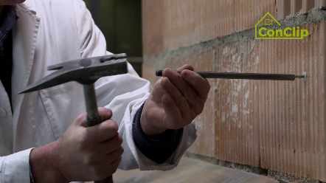 | 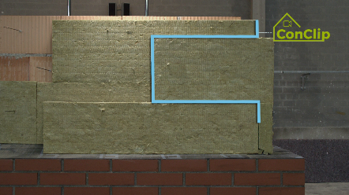 | 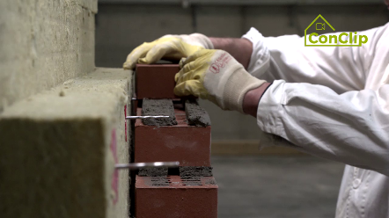

About ConClips
ConClips are short video clips (3 to 4 minutes) about the proper fitting of construction and installation parts in passive houses. As an easy understandable multimedia tool helping workers to fill skill gaps, ConClips can be integrated in vocational training and education.
The teaching material serves instructors and other experts as a basis for using ConClips in teaching that can be extended according to their own requirements.

ConClips: The making of
Each ConClip highlights one specific working process.
A worker performs the work steps in a realistic 1:1-scale model of the working environment.
An off-speaker gives short, understandable explanations to the work steps.
Additionally, the most important work steps and terms (keywords) appear as text inserts.
In the end, the most important steps and keywords are repeated.

Code of didactical practice
On the following page, you find material to the video, split in the following categories:
- The working procedure as shown in the video is divided into a sequence of comprehensible workflow steps
- The workflow steps are explained on three levels:
- What is done?
- How is it done?
- Why is it done?
- A small number of keywords relevant for the workflow are introduced and defined.
Please add the contents relevant for Your teaching – e.g. catchwords of explanation (Why something has to be done?) resp. keywords and a definition of them.

Workflow Steps
What is done? | How is it done? | Why is it done?
Correct insulation of cavity walls
Flatten the surface of the bearing wall. | Remove all protruding mortar residues. | A flattened surface ensures there are no cavities between the insulation and the supporting wall.
Attach a moisture sealing on the base point.
Attach water-repellent insulation on the base point. | Attach two layers of water-repellent insulation boards.
 | Cut the repellent insulation boards so that they have an outward slope on the upper side.
Put a layer of Moisture sealing on the water-repellent insulation. | Heat the upper moisture sealing with hot air. | Because of the sealing’s outward slope, moisture will not be kept in the wall cavity.
 | Then press it firmly on the clinker wall.
Drill holes for the cavity wall anchors and introduce the anchors. | Follow the manufacturer’s instructions about the necessary number and spacing of the anchors. | The wall ties (anchors) are necessary for the stability / transverse rigidity of the outer wall.
Attach the two layers of insulation boards on the supporting wall. | Start insulating in the corner.
 | Cut the bottom insulation boards at angle (according to the moisture sealing’s outward slope).
 | Push the boards over the anchor.
 | The boards must be staggered in each row.
 | To keep the second layer of insulation boards tight to the first one, use plastic clips which are put on the anchors. | As the insulation boards are closely attached to each other, there is space for rear ventilation between the boards and the outer wall.
Assemble the exposed brickwork (the outer wall) | Use a wooden plate to keep the air space (between the insulation boards and the exposed brickwork) free from mortar. Remove this wooden plate before assembling the next row of tiles. | The rear ventilation space has to be kept free from mortar and other dirt.
 | Grout well the anchors in the bed joints. | Connecting the outer wall to the supporting wall, the anchors are crucial for the outer wall’s stability.
Leave open vertical joints for rear ventilation. | Set those cavities at the lower and upper end of the façade.

Correct insulation of cavity walls: KEywords
Insulation | Especially in climates with a heating demand the entire building envelope has to be well insulated. The building envelope consists of all the building elements which separate the inside from the outside. Its main purpose is to provide for a comfortable indoor climate – irrespective of the outdoor climate which is determined by the weather.
Supporting wall | The inner, load-bearing wall at cavity wall constructions.
Exposed brickwork | The outer wall. As an alternative to the brickwork shown in the clip, also calcareous sandstone in thin-bed mortar is used frequently in passive houses construction.

